Task 1:
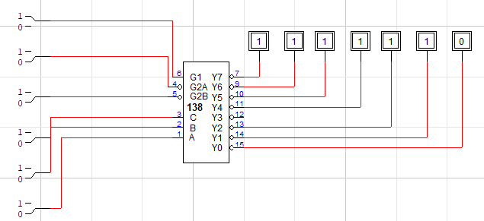
INPUTS |  |  |  |  |  | OUTPUTS
Enable |  |  | Select
G1 | G2A’ | G2B’ | A2 | A1 | A0 | Y0’ | Y1’ | Y2’ | Y3’ | Y4’ | Y5’ | Y6’ | Y7’
1 | 0 | 0 | 0 | 0 | 0 | 0 | 1 | 1 | 1 | 1 | 1 | 1 | 1
1 | 0 | 0 | 0 | 0 | 1 | 1 | 0 | 1 | 1 | 1 | 1 | 1 | 1
1 | 0 | 0 | 0 | 1 | 0 | 1 | 1 | 0 | 1 | 1 | 1 | 1 | 1
1 | 0 | 0 | 0 | 1 | 1 | 1 | 1 | 1 | 0 | 1 | 1 | 1 | 1
1 | 0 | 0 | 1 | 0 | 0 | 1 | 1 | 1 | 1 | 0 | 1 | 1 | 1
1 | 0 | 0 | 1 | 0 | 1 | 1 | 1 | 1 | 1 | 1 | 0 | 1 | 1
1 | 0 | 0 | 1 | 1 | 0 | 1 | 1 | 1 | 1 | 1 | 1 | 0 | 1
1 | 0 | 0 | 1 | 1 | 1 | 1 | 1 | 1 | 1 | 1 | 1 | 1 | 0

Task 2:
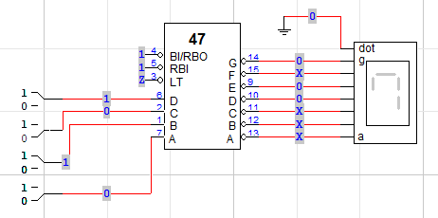
INPUTS |  |  |  | OUTPUTS
A3 | A2 | A1 | A0 | a’ | b’ | c’ | d’ | e’ | f’ | g’
0 | 0 | 0 | 0 | 0 | 0 | 0 | 0 | 0 | 0 | 1
0 | 0 | 0 | 1 | 1 | 0 | 0 | 1 | 1 | 1 | 1
0 | 0 | 1 | 0 | 0 | 0 | 1 | 0 | 0 | 1 | 0
0 | 0 | 1 | 1 | 0 | 0 | 0 | 0 | 1 | 1 | 0
0 | 1 | 0 | 0 | 1 | 0 | 0 | 0 | 1 | 0 | 0
0 | 1 | 0 | 1 | 0 | 1 | 0 | 0 | 1 | 0 | 0
0 | 1 | 1 | 0 | 0 | 1 | 0 | 0 | 0 | 0 | 0
0 | 1 | 1 | 1 | 0 | 0 | 0 | 1 | 1 | 1 | 1
1 | 0 | 0 | 0 | 0 | 0 | 0 | 0 | 0 | 0 | 0
1 | 0 | 0 | 1 | 0 | 0 | 0 | 0 | 1 | 0 | 0

Task 3:
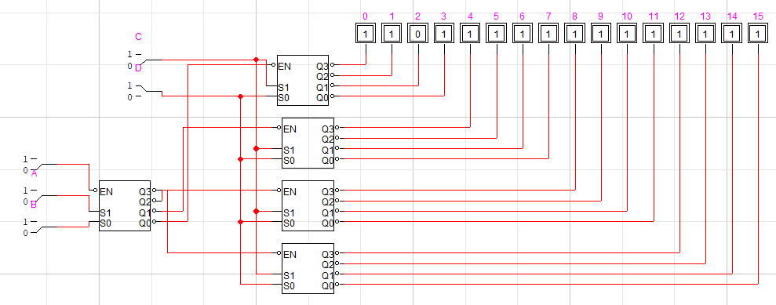
Task 4:
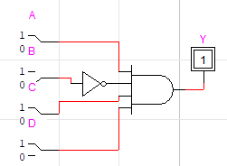
Task 5:
a) 1110
b) 1100
c) 1111
d) 1001
Task 6:
1st figure: Correct output should be 9. Circuit is working correctly.
2nd figure: Correct output should be 1. Display shows 0.

Possible faults:
- Segments a, d, e, f stuck ON
- Decoder outputs for these segments shorted to LOW
- Wrong wiring between decoder and display
3rd figure: Correct output should be 6. Display shows 8.

Possible faults:
    - All outputs stuck LOW
    - Faulty decoder IC
    - Short circuit in outputs
Task 7:
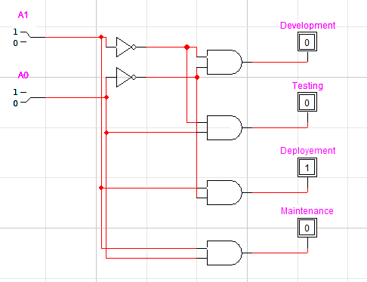
Task 8:
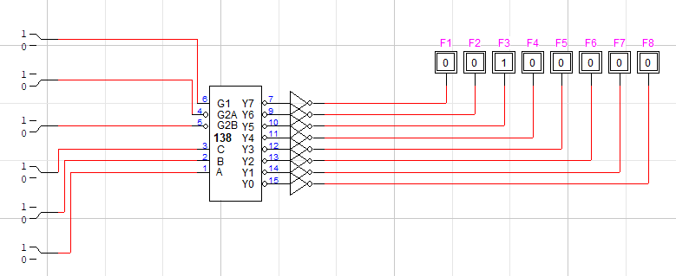
The outputs of 74LS138 are active LOW, meaning:
- Selected feature line = 0 (LOW)
- But usually systems expect 1 (HIGH) to enable.
Task 9:
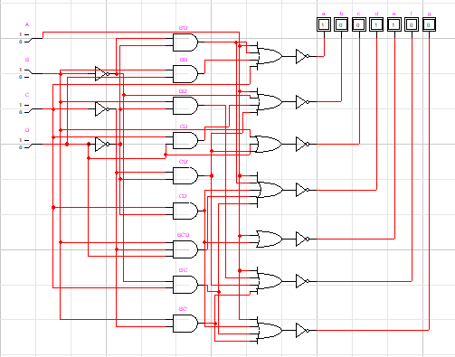
Task 10:
